CLIFTONETTES JUNIOR NETBALL CLUB
Pontins U13 Netball Tournament – Saturday 29th and Sunday 30th June 2008

Squad: Alice Avison Lydia Bailey Ciara Bamford Abbie Flewitt Imogen Harrison Izzy Rotherham Beth Selwyn Suzanne Tomkins Katie Wright

Team Manager: Emily Leigh

Umpires: Jill Bullock and Carolyn Robinson

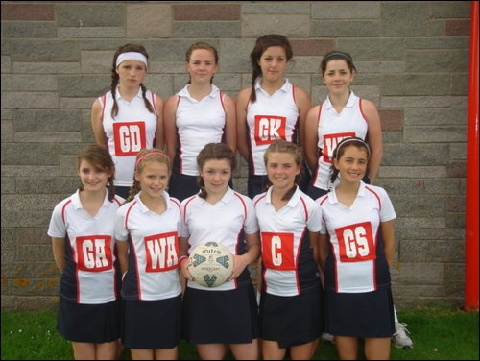

Saturday Results:
Opposition | Score
Treharris Netball Club | Won 13-0
Conquerors Vikings | Lost 2-8
Copeswood Diamonds B | Won 8-2
Sutton Coldfield | Won 6-2
Hucclecote | Won 5-4
Finchampstead A | Lost 4-7
Bridgwater | Won 5-1

Good preparation on the Saturday morning of sleeping, eating and playing on the beach, saw the girls get off to an excellent start with a 13-0 win against Treharris. Spirits were high, however we were brought back down to earth with a bump with a defeat to Conquerors Vikings, who we were drawing with at half time. The team picked themselves back up though, and some great shooting from Suzy, Beth and Katie gave us three wins on the run. The best performance of the day was a narrow 5-4 win against Hucclecote, thanks to some top class defending from Imogen and Lydia, and Abbie (WA) and Ciara (WD) showing just how versatile they can be. Finchampstead A were a strong team last year, and again beat us, before determination from Izzy and Alice gave us victory over Bridgwater to guarantee a 3rd place finish and qualification for the Cup competition.

Sunday Results:
Opposition | Score
Fenton Manor | Lost 5-6
Chelmsford Cosmics | Lost 1-6
Copeswood Diamonds A | Lost 3-6

Sunday was a lot tougher, and we were extremely unlucky not to have got more points in our first match, with Fenton scoring 2 late goals to take the victory. Chelmsford were a strong team, and we unfortunately lost Lydia to a twisted ankle late in the second half. The game was abandoned at 1-6, with about 4 minutes to play. The girls re-grouped for the final match, and with Lydia and her ice-pack cheering from the sidelines, they put in a great performance to get 50% of the score against Copeswood Diamonds A.

Overall, the girls showed great team spirit and maturity throughout the entire weekend. They played some excellent netball and were a pleasure to be with. Well done to Katie who was awarded Manager’s Player of the Tournament, and Abbie who was voted Player’s Player of the Tournament.

